Electric Power Systems Research

Dear Dr. Derald,

Kindly find the attached revision of the paper entitled “Distance Protection Zone 3 Misoperation During System Wide Cascading Events: The Problem and a Survey of Solutions” which we are submitting for exclusive consideration for Electric Power Systems Research.

We would like to thank you and the reviewers for the time and effort put towards the publication of this paper. We agree with the comments of the reviewers and updated the paper accordingly. We have attached the response to the reviewers separately.

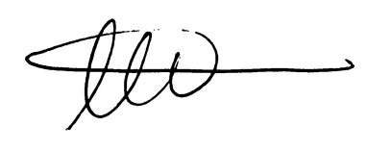

Ahmad Abdullah

Power System Design Engineer

Electric Power Engineers Inc.,

Austin, TX, 78738